**ASSIGNMENT - 1**

Name: **HITARTH GANATRA**

Sem: **II**

Div.: **1**

ID: **22BCA064**

Subject: **Fundamentals of Object Oriented Programming Language**

Q1

**CODE:**

// Write a C++ program to print Hello World

#include<iostream>

using namespace std;

int main(){

    cout << "Hello World";

    return 0;

}

**OUTPUT:**



**Q2**

**CODE:**

// Write a C++ program to display any number entered by the user

#include<iostream>

using namespace std;

int main(){

    int num;

    cout << "Enter a number: ";

    cin >> num;

    cout << "You entered: " << num;

    return 0;

}

**OUTPUT:**



Q3

**CODE:**

// Write a C++ program to input three numbers and display its total and average.

#include<iostream>

using namespace std;

int main(){

    int num1, num2, num3;

    cout << "Enter three numbers: ";

    cin >> num1 >> num2 >> num3;

    cout << "Total: " << num1 + num2 + num3 << endl;

    cout << "Average: " << (num1 + num2 + num3) / 3;

    return 0;

}

**OUTPUT:**

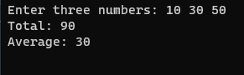

Q4

**CODE:**

// Write a C++ program to enter Day Temperature of 5 cities of Gujarat. Display average temperature.

#include<iostream>

using namespace std;

int main(){

    int dayTemp1, dayTemp2, dayTemp3, dayTemp4, dayTemp5;

    cout << "Enter Day Temperature of 5 cities of Gujarat: ";

    cin >> dayTemp1 >> dayTemp2 >> dayTemp3 >> dayTemp4 >> dayTemp5;

    cout << "Average Temperature is: " << (dayTemp1 + dayTemp2 + dayTemp3 + dayTemp4 + dayTemp5) / 5;

    return 0;

}

**OUTPUT:**



Q5

**CODE:**

// Write a C++ program to find simple interest

#include<iostream>

using namespace std;

int main(){

    int p, r, t;

    cout << "Enter Principal, Rate and Time: ";

    cin >> p >> r >> t;

    cout << "Simple Interest is: " << (p * r * t) / 100;

    return 0;

}

**OUTPUT:**

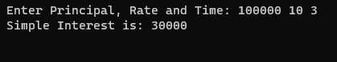

Q6

**CODE:**

// WAP to find area of circle

#include<iostream>

using namespace std;

#define PI 3.14

int main(){

    float radius;

    cout << "Enter the radius : ";

    cin >> radius;

    cout << "The Area of Circle with Radius " << radius << " is " << PI * radius * radius << endl;

    return 0;

}

**OUTPUT:**

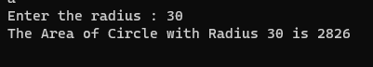

Q7

**CODE:**

// Write a C++ program to read two numbers from user and print their addition, subtraction, multiplication and division on screen.

#include<iostream>

using namespace std;

int main(){

    int a, b;

    cout << "Enter First Number: ";

    cin >> a;

    cout << "Enter Second Number: ";

    cin >> b;

    cout << "The sum of " << a << " and " << b << " is " << a + b << endl;

    cout << "The difference of " << a << " and " << b << " is " << a - b << endl;

    cout << "The multiplication of " << a << " and " << b << " is " << a * b << endl;

    cout << "The division of " << a << " and " << b << " is " << a / b << endl;

    return 0;

}

**OUTPUT:**

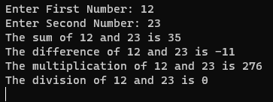

Q8

**CODE:**

// 8.   Write a C++ program to input marks of five subjects of a student and calculate total marks and percentage.

#include<iostream>

using namespace std;

int main(){

    int sub1, sub2, sub3, sub4, sub5;

    cout << "Enter marks of five subjects: ";

    cin >> sub1 >> sub2 >> sub3 >> sub4 >> sub5;

    cout << "Total Marks: " << sub1 + sub2 + sub3 + sub4 + sub5 << endl;

    cout << "Percentage: " << (sub1 + sub2 + sub3 + sub4 + sub5) / 5 << endl;

    return 0;

}

**OUTPUT:**



Q9

**CODE:**

// WAP to find whether the entered number is odd or even.

#include<iostream>

using namespace std;

int main(){

    int num;

    cout << "Enter a number: ";

    cin >> num;

    if(num % 2 == 0){

        cout << "The number is even";

    }

    else{

        cout << "The number is odd";

    }

    return 0;

}

**OUTPUT:**

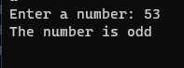



Q10

**CODE:**

// WAP to print below pattern (no. of rows: 5):

// *

// * *

// * * *

// * * * *

// * * * * *

#include<iostream>

using namespace std;

int main(){

    int rows;

    cout << "Enter number of rows: ";

    cin >> rows;

    for(int i = 1; i <= rows; i++){

        for(int j = 1; j <= i; j++){

            cout << "* ";

        }

        cout << endl;

    }

    return 0;

}

**OUTPUT:**

